TEMPLATE SOURCE CODE DOCUMENTATION
DOKUMENTASI KOD SUMBER BAGI SISTEM < Sistem Pengurusan Pusat Gym >
Versi | Tarikh Diluluskan | Pemilik
1.0 | 0.1.11.2026 | Muhammad Taufiq Bin Ismail

1. Tujuan
Dokumentasi ini bertujuan sebagai keperluan untuk mengurus kod sumber, memastikan kawalan versi, mengurus dokumen berkaitan dan mengawal risiko kehilangan kod sumber.

2. Maklumat Asas
2.1 Sistem
• Sistem Pengurusan Pusat Gym merupakan sebuah sistem berasaskan web yang dibangunkan untuk memudahkan urusan pengurusan dan pendaftaran ahli gimnasium.
• Sistem ini mempunyai fungsi log masuk (Login) bagi memastikan pengguna dapat mengakses sistem.
• BMI CALCULATOR
• Nama sistem: Sistem Pengurusan Pusat GYM
• Sistem ini menggunakan JavaScript untuk melaksanakan fungsi pengesahan maklumat dan pengiraan BMI.
• Secara keseluruhannya, sistem ini dibangunkan bagi meningkatkan kemudahan, kecekapan dan sistematik dalam pengurusan pusat gim.

TEMPLATE SOURCE CODE DOCUMENTATION
2.2 Rujukan Projek
1.Contoh Website
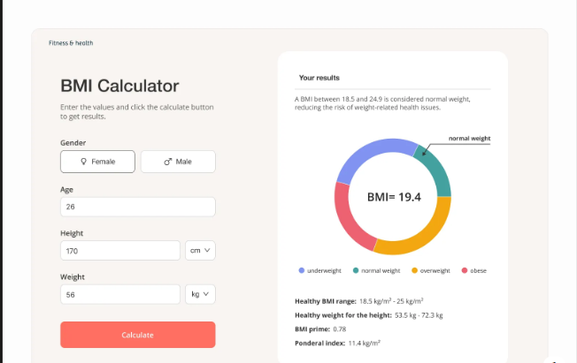
2.Contoh Ujian BMI
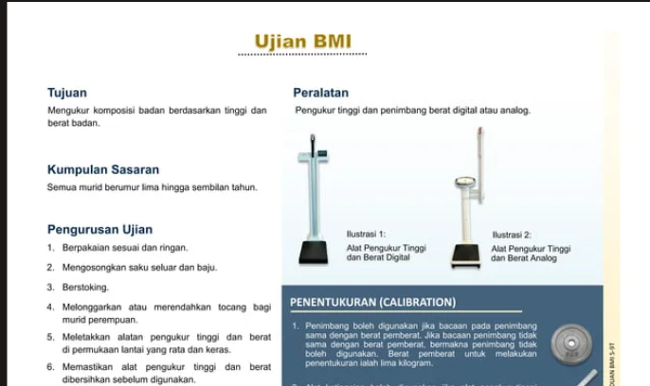
3.Contoh buku menerang BMI
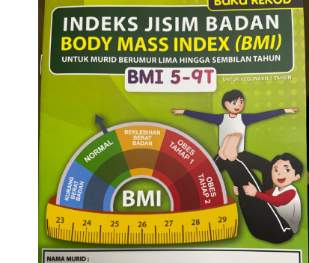

2.3 Hubungi
Nama:Muhammad Taufiq Bin Ismail 2KPD SEMESTER 4
No_Telefon:011-1781-1985
No_Kerja:019-476-2599
Email: taufiq5676@gmail.com
Sosial Media: @NeoCantTalk

TEMPLATE SOURCE CODE DOCUMENTATION
3. Kod Sumber
Skrin pertama:
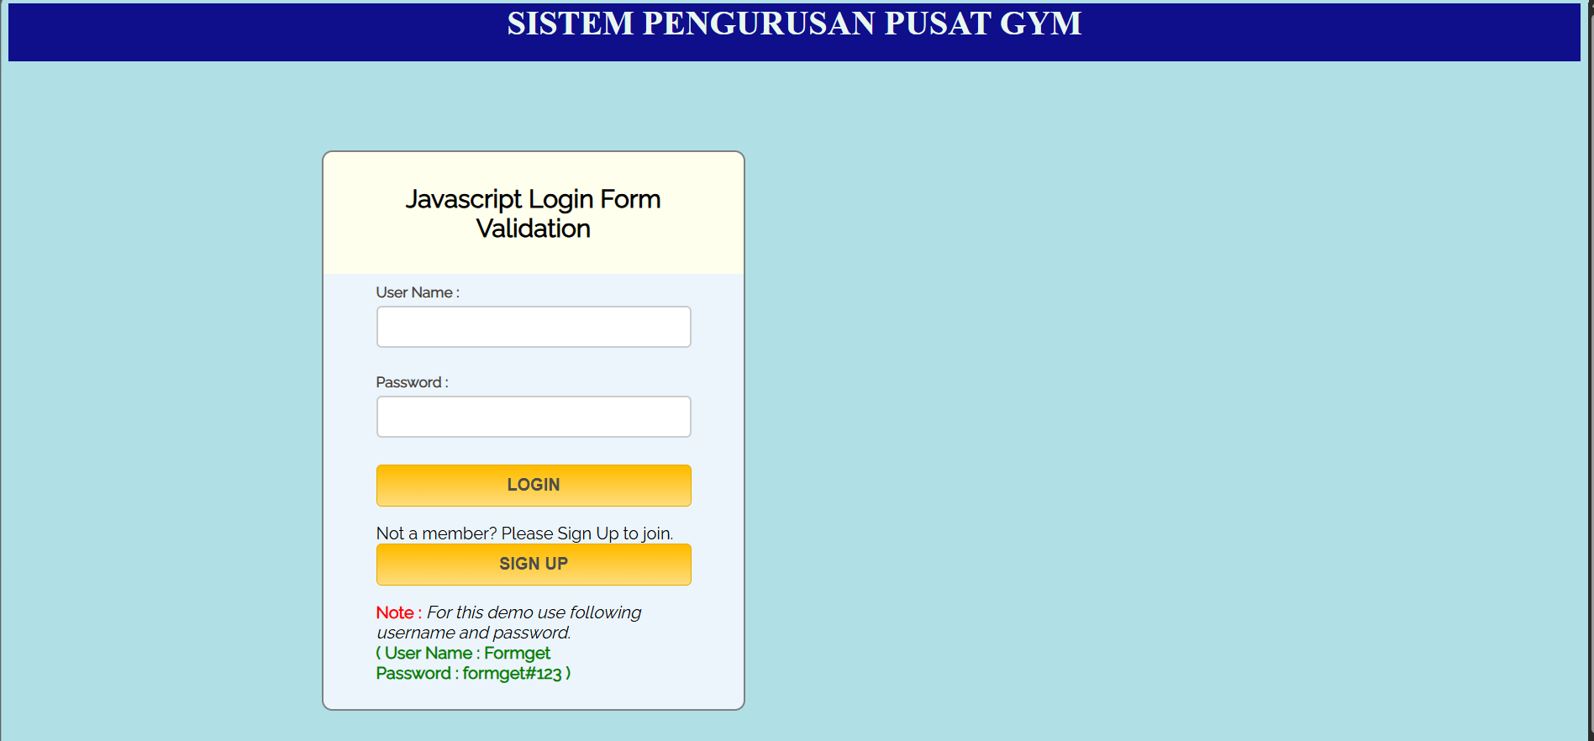
Kod Sumber:
<html>
<head>
<title> LOGIN Validationm </title>
<!-- Include CSS File Here -->
<link rel="stylesheet" href="logStyle.css"/>
<!-- Include JS File Here -->
<script src="login2.js"></script>
</head>
<body>
<body style="background-color:powderblue;">

<div style="background-color:#0F0F8C; height:55px">
<CENTER><H4 style="color:#E9F7EF">SISTEM PENGURUSAN
PUSAT GYM</h4 </CENTER>
</div>

<div class="container">
<div class="main">
<h2>Javascript Login Form Validation</h2>
<form id="form_id" method="post" name="myform"> <br>
<label>User Name :</label>
<input type="text" name="username" id="username"/>
<label>Password :</label>
<input type="password" name="password" id="password">

<input type="button" value="LOGIN" id="submit" onclick="validate()"/>
<BR> <p> Not a member? Please Sign Up to join.
<input type="button" value="SIGN UP" id="submit" onclick="window.location.href='FORM2_print.html'"/>
</form>
<span><b class="note">Note : </b> <I> For this demo use following username and password. </I>
<br/><b class="valid"> ( User Name : Formget <br/> Password : formget#123 )</b></span>
</div>
</div>

Skin Kedua:
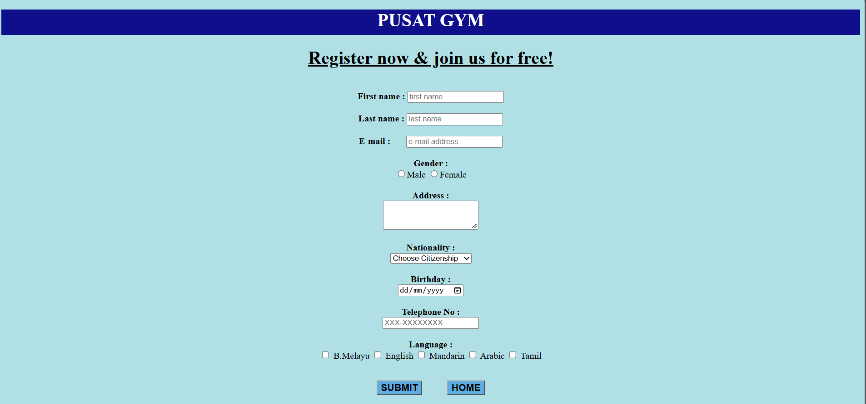
Kod Sumber:
<!DOCTYPE html>
<html>
<head>
<title>Web Form</title>
<!--link rel='stylesheet' type='text/css' href=''/>
<link href='http://fonts.googleapis.com/css?family=Lobster' rel='stylesheet' type='text/css'-->
<script src="https://ajax.googleapis.com/ajax/libs/jquery/2.1.1/jquery.min.js"> </script>
<!--script src="Scripts/jquery-1.4.1.js" type="text/javascript"></script-->
<!--script src="Scripts/jquery-1.4.1-vsdoc.js" type="text/javascript"></script-->
<script >
function display() {
DispWin = window.open('','NewWin','toolbar=yes,status=yes,width=700,height=500')
var items=document.getElementsByName('langz');
var selectItems="";
for(var i=0; i<items.length; i++){
if(items[i].type=='checkbox' && items[i].checked==true)
selectItems+= " ~ " + items[i].value;
}

message = "<b>THANK YOU!</b><BR> Now you can enjoy membership benefits. Here are your details upon registration:- <pre>" ;
message += "<ul><li>Fisrst NAME: <b>" + document.answer.firstName.value + "</b>";
message += "<li> Last Name : <b>" + document.answer.lastName.value + "</b>";
message += "<li> E-mail : <b>" + document.answer.email.value + "</b>";
message += "<li> Gender : <b>" + document.answer.gen.value + "</b>";
message += "<li> Address : <b>" + document.answer.addr.value + "</b>";
message += "<li> Nationality : <b>" + document.answer.nation.value + "</b>";
message += "<li> Birthday : <b>" + document.answer.bday.value + "</b>";
message += "<li> Contact no. : <b>" + document.answer.telno.value + "</b>";
message += "<li> Language :" + (selectItems) + "</ul>" + "<br>" +
'<br> <input type="button" value="Print" onclick="window.print()" />' ;
DispWin.document.write(message);
}
</script> </head>
<body>
<body style="background-color:powderblue;"> <center>
<div style="background-color:#0F0F8C ;height:45px">
<CENTER><h1 style="color:white">PUSAT GYM</h1> </CENTER>
</div>

<div id="header"><h1><u>Register now & join us for free!</u></h1></div>
<br><div id="wrapper">
<form name="answer" action=" " method="post" id="answers" autofocus>
<b>First name :</b> <input type="text" name="firstName" id="fname" placeholder="first name"><br/>
<br><b>Last name :</b> <input type="text" name="lastName" placeholder="last name" id="lname"> <br/>
<br><b>E-mail :</b> &nbsp; &nbsp; &nbsp;
<input type="email" name="email" placeholder="e-mail address" id="mail"> <br/><br/>
<b>Gender :</b><br>
<input type="radio" name="gen" value="male">Male
<input type="radio" name="gen" value="female">Female<br/>
<br><b>Address :</b><br/>
<textarea name="addr" rows="3" placeholder="your home address.."> </textarea>
<br><br> <b>Nationality :</b> <br>
<select name="nation" id="nations" >
<option value="default" checked>Choose Citizenship</option>
<option value="Citizen">Citizen </option>
<option value="Permanent Resident">Permanent Resident </option>
<option value="Non_Citizen">Non-Citizen </option></select><br>
<br><b> Birthday : </b><br>
<input type="date" name="bday" format="dd-mm-yyyy"> <br/>
<br><b> Telephone No : </b><br>
<input type="password" name="telno" id="telno" maxlength="10" placeholder="XXX-XXXXXXXX" >
<br/>
<div id="inputx" name="choices" class="choice" >
<br><b>Language :</b><br>
<input class="choice" type="checkbox" name="langz" value="B.MELAYU" > B.Melayu
<input class="choice" type="checkbox" name="langz" value="ENGLISH" > English
<input class="choice" type="checkbox" name="langz" value="MANDARIN" > Mandarin
<input class="choice" type="checkbox" name="langz" value="ARABIC" > Arabic
<input class="choice" type="checkbox" name="langz" value="TAMIL" > Tamil
</div>
<br><p>
<input type="submit" id="submit" value="SUBMIT" onclick="display()" style="font-weight:bold; font-size:17px; width:auto; background-color:#5DADE2">
&nbsp; &nbsp; &nbsp; &nbsp; &nbsp;
<input type="reset" id="submit" value="HOME" onclick="window.location.href='Login2.html'" style="font-weight:bold; font-size:17px; width:auto; background-color:#5DADE2" />
</form>
</div>
</body></html>
Skin Ketiga:
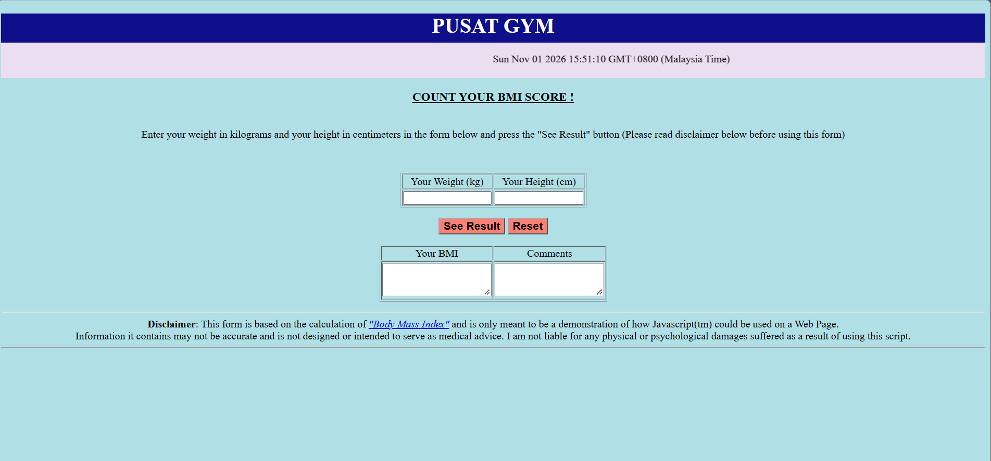
Kod Sumber:
<!DOCTYPE html>
<html>
<head>
<title> </title>
</head>
<body>
<body style="background-color:powderblue;">
<div style="background-color:#0F0F8C ;height:45px">
<CENTER><h1 style="color:white">PUSAT GYM</h1> </CENTER>
</div>
<div header style="background-color:#EBDEF0;" ><center>

<marquee>
<p id="demo"></p>
</marquee>

</div>

<CENTER><H3><U> COUNT YOUR BMI SCORE ! </U></H3></CENTER>

<center><br>
Enter your weight in kilograms and your height in centimeters in the form below and press the "See Result" button (Please read disclaimer below before using this form)
<P> <br>
<FORM NAME="BMI" method=POST>
<TABLE border=1>
<TR>
<TD><DIV ALIGN=CENTER> Your Weight (kg)</DIV></TD>
<TD><DIV ALIGN=CENTER> Your Height (cm)</DIV></TD>

</TR>
<TR>
<TD><INPUT TYPE=TEXT NAME=weight SIZE=15 onFocus="this.form.weight.value=''" maxlength=3></TD>
<TD><INPUT TYPE=TEXT NAME=height SIZE=15 onFocus="this.form.height.value=''" maxlength=3></TD>
</TR>
</TABLE>

<P>
<INPUT TYPE="button" VALUE="See Result" onClick="computeform(this.form)" style="font-weight:bold; font-size:17px; width:auto; background-color:salmon" >
<INPUT TYPE="reset" VALUE="Reset" onClick="ClearForm(this.form)" style="font-weight:bold; font-size:17px; width:auto; background-color:salmon" >

<!--/FORM-->

<TABLE border=1>
<TR>
<TD><DIV ALIGN=CENTER> Your BMI </DIV></TD>
<TD ><DIV ALIGN=CENTER> Comments </DIV></TD>
</TR>
<TR>

<TD rowspan="2"><textarea rows="3" NAME=bmi SIZE=8 readonly> </textarea></TD>
<TD rowspan="2" ><textarea rows="3" NAME=my_comment size=55 readonly> </textarea></TD>

</TABLE>
</FORM>

<P><HR>
<B>Disclaimer</B>: This form is based on the calculation of
<A HREF="http://phaster.com/unpretentious/bmi.html"><I>"Body Mass Index"</I></A>
and is only meant to be a demonstration of how Javascript(tm) could be used
on a Web Page.
<br>Information it contains may not be accurate and is not designed or intended to serve as medical advice. I am not liable for any physical or psychological damages suffered as a result of using this script.

<!--p>This free script provided by
<a href="http://javascriptkit.com">JavaScript
Kit</a></p-->
<hr>

<SCRIPT LANGUAGE="JAVASCRIPT">
// hide this script tag's contents from old browsers

//Body Mass calculator- by John Scott (johnscott03@yahoo.com)
//Visit JavaScript Kit (http://javascriptkit.com) for script
//Credit must stay intact for use

var d = new Date();
document.getElementById("demo").innerHTML = d;

function ClearForm(form){

form.weight.value = "";
form.height.value = "";
form.bmi.value = "";
form.my_comment.value = "";

}

function bmi(weight, height) {

bmindx=weight/eval(height*height);
return bmindx;
}

function checkform(form) {

if (form.weight.value==null||form.weight.value.length==0 || form.height.value==null||form.height.value.length==0){
alert("\nPlease complete the form first");
return false;
}

else if (parseFloat(form.height.value) <= 0||
parseFloat(form.height.value) >=500||
parseFloat(form.weight.value) <= 0||
parseFloat(form.weight.value) >=500){
alert("\nReally know what you're doing? \nPlease enter values again. \nWeight in kilos and \nheight in cm");
ClearForm(form);
return false;
}
return true;

}

function computeform(form) {

if (checkform(form)) {

yourbmi=Math.round(bmi(form.weight.value, form.height.value/100));
form.bmi.value=yourbmi;

if (yourbmi >40) {
form.my_comment.value="You are grossly obese, consult your physician!";
}

else if (yourbmi >30 && yourbmi <=40) {
form.my_comment.value="Umm... You are obese, want some liposuction?";
}

else if (yourbmi >27 && yourbmi <=30) {
form.my_comment.value="You are very fat, do something before it's too late";
}

else if (yourbmi >22 && yourbmi <=27) {
form.my_comment.value="You are fat, need dieting and exercise";
}

else if (yourbmi >=21 && yourbmi <=22) {
form.my_comment.value="I envy you. Keep it up!!";
}

else if (yourbmi >=18 && yourbmi <21) {
form.my_comment.value="You are thin, eat more.";
}

else if (yourbmi >=16 && yourbmi <18) {
form.my_comment.value="You are starving. Go Find some food!";
}

else if (yourbmi <16) {
form.my_comment.value="You're grossly undernourished, need hospitalization ";
}

}
return;
}
// -- done hiding from old browsers -->
</SCRIPT>
</body>
</html>
-mesti ada komen
Contoh:
<html>
<head>
<title>PHP Test</title>
</head>
// mula menulis Bahasa php
<body>
<?php echo '<p>Hello World</p>'; ?>
</body>
</html>

